Exam 1

Patrick Ha
IS 257 S01 Big Data Analytics
Professor Wibbenmeyer
October 10, 2024

Exam 1
- What types of product units do they sell?
They sell candy, chocolate, lollypops, brittle, toffee, wafers, and nuts.
- What is the smallest unit? What is the largest unit?
The smallest unit is Extra Fancy Mixed Salted Nuts. Boxed chocolates.
- Try out their online ordering process. (Don’t order candy unless you plan to pay for it yourself! What is their online booking process like? When you place an order, what transaction data do they gather?
When you pick options, they give you a size to pick, the color of the gift wrap. It gives you an option to either do a one-time purchase or sign up for auto delivery, and then it gives you an option to choose how many you want. Then, you can click add to bag. Once you add it to your bag, it will give you a subtotal of the cost, and then you can click review bag and check out. When you are ready to place an order, you can either create an account login or check out as guest. They give you an option to use PayPal and an option to enter a promo code. It gives you a shipping address to input, so they know where to send the package. After that, they let you select the shipping method, so you can pick the normal standard delivery which is the $9.95 or select the date on a calendar. It gives you a date to choose and it has the prices. If you wait about 3 weeks, the shipping is free. Then, they collect your payment method and the billing address. Lastly, you get to review your products that you put into the bag and the payment method you chose. Then, you submit the order.
- When you try to order candy online, what customer data do they gather?
They collect your shipping address, name, phone number, and email.
- When you order candy online, what payment data do they gather?
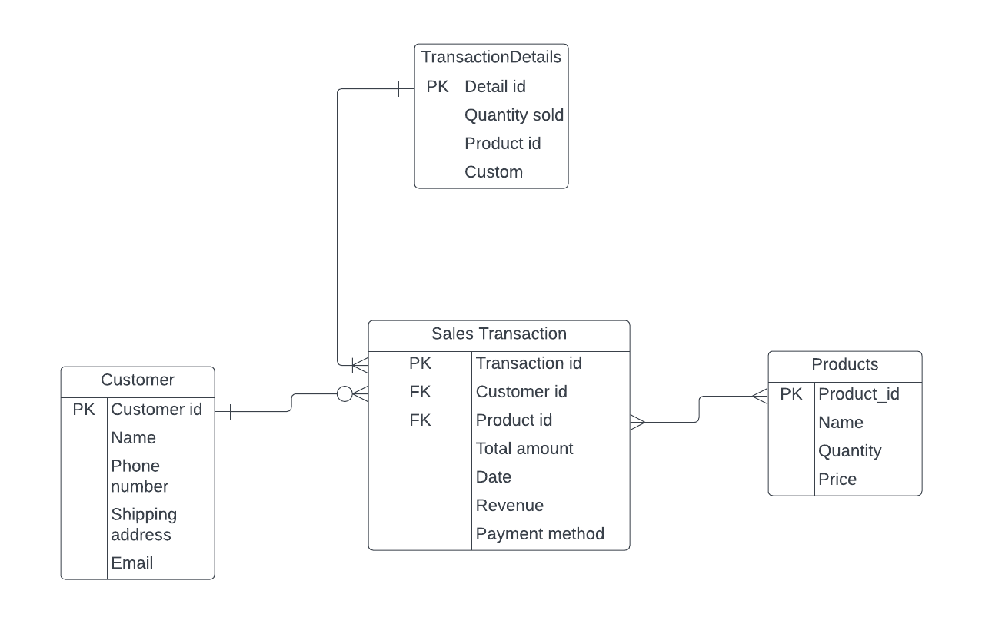
They collect your credit card number, expiration date and year, and security code.
